**Assignment -4**

Python Programming

| Assignment Date | 6 October 2022 |
| --- | --- |
| Student Name | Prawin.R |
| Student Roll Number | 722819104104 |
| Maximum Marks | 2 Marks |

**Question-1:**

Write code and connections in wokwi for the ultrasonic sensor. Whenever the distance is less than 100 cms send an "alert" to the IBM cloud and display in the device recent events. Upload document with wokwi share link and images of IBM cloud

**SOLUTION :**

#include <WiFi.h>

#include <PubSubClient.h>

#define TRIGGER 2

#define ECHO 15

#define sound_speed 0.034

int distance;

void callback(char* subscribetopic, byte* payload, unsigned int payloadLength);

//-------credentials of IBM Accounts------

#define ORG "9a7ip9"

#define DEVICE_TYPE "NodeMCU"

#define DEVICE_ID "7010300"

#define TOKEN "3ABPWOR(cHHSs!-mA+"

String data3;

//-------- Customise the above values --------

char server[] = ORG ".messaging.internetofthings.ibmcloud.com";

char publishTopic[] = "iot-2/evt/Data/fmt/json";

char subscribetopic[] = "iot-2/cmd/test/fmt/String";

char authMethod[] = "use-token-auth";

char token[] = TOKEN;

char clientId[] = "d:" ORG ":" DEVICE_TYPE ":" DEVICE_ID;

//-----------------------------------------

WiFiClient wifiClient;

PubSubClient client(server, 1883, callback ,wifiClient);

void setup()

{

Serial.begin(115200);

pinMode(TRIGGER, OUTPUT);

pinMode(ECHO, INPUT);

delay(10);

Serial.println();

wificonnect();

mqttconnect();

}

void loop()

{

digitalWrite(TRIGGER, HIGH);

delayMicroseconds(10);

digitalWrite(TRIGGER, LOW);

int duration=pulseIn(ECHO,HIGH);

distance=(duration*sound_speed)/2;

Serial.print(distance);

Serial.println(" cms.");

if(distance>100){

PublishData(distance);

}

delay(1000);

if (!client.loop()) {

mqttconnect();

}

}

/.....................................retrieving to Cloud.............................../

void PublishData(int d) {

mqttconnect();

String payload = "{\"message\":\"alert\"";

payload += "}";

Serial.print("Sending payload: ");

Serial.println(payload);

if (client.publish(publishTopic, (char*) payload.c_str())) {

Serial.println("Publish ok");

} else {

Serial.println("Publish failed");

}

}

void mqttconnect() {

if (!client.connected()) {

Serial.print("Reconnecting client to ");

Serial.println(server);

while (!!!client.connect(clientId, authMethod, token)) {

Serial.print(".");

delay(500);

}

initManagedDevice();

Serial.println();

}

}

void wificonnect()

{

Serial.println();

Serial.print("Connecting to ");

WiFi.begin("Wokwi-GUEST", "", 6);

while (WiFi.status() != WL_CONNECTED) {

delay(500);

Serial.print(".");

}

Serial.println("");

Serial.println("WiFi connected");

Serial.println("IP address: ");

Serial.println(WiFi.localIP());

}

void initManagedDevice() {

if (client.subscribe(subscribetopic)) {

Serial.println((subscribetopic));

Serial.println("subscribe to cmd OK");

} else {

Serial.println("subscribe to cmd FAILED");

}

}

void callback(char* subscribetopic, byte* payload, unsigned int payloadLength)

{

Serial.print("callback invoked for topic: ");

Serial.println(subscribetopic);

for (int i = 0; i < payloadLength; i++) {

//Serial.print((char)payload[i]);

data3 += (char)payload[i];

}

Serial.println("data: "+ data3);

data3="";

}

**OUTPUT :**

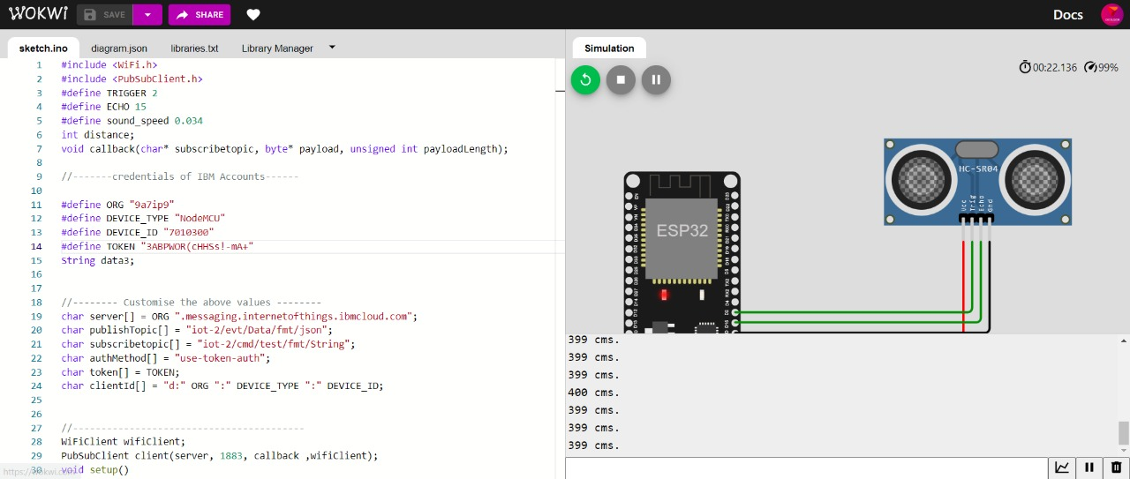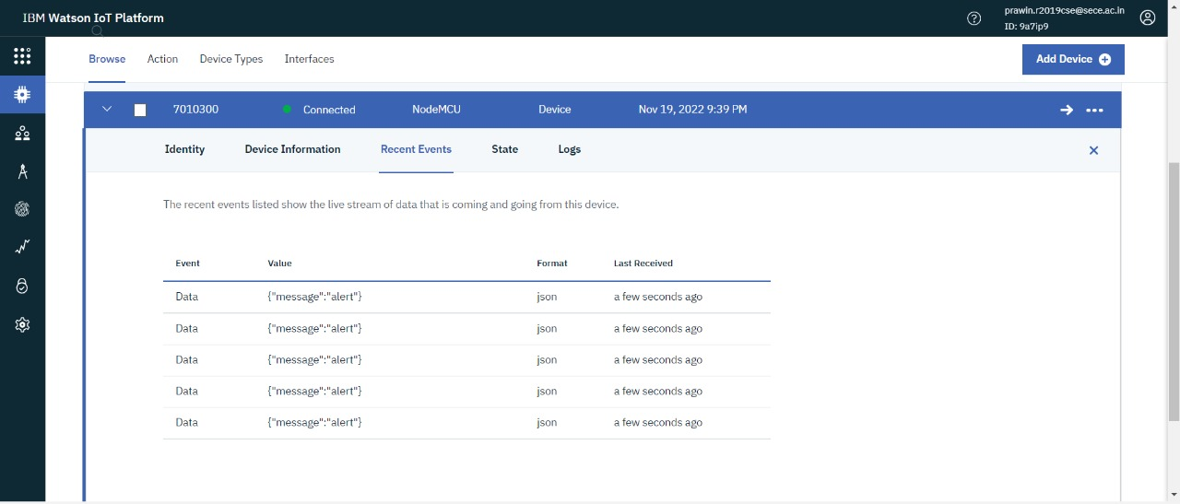

**REFERENCE : https://wokwi.com/projects/348777546523869778**